PROJECT DOCUMENTATION
FINAL REPORT


TOPIC:
Bank Management System Software
TEAM:
Rollno | Name
BITF24A021 | Zain Ali
Bitf24a007 | Abdul Ahad

Submitted to: Sir Anzar Asst. Professor

TABLE OF CONTENTS

Project Report:……………………………………………………………...3
Introduction:…………………………………………………………………4
Domain Model:………………………………………………………………5
Use Case Documentation:………………………………………………7
Activity Diagram:………………………………………………………….10

Project Report:
Problem
A commercial bank requires a reliable and efficient software system to manage its core banking operations. Existing manual and fragmented systems make it difficult to handle customer records, account management, financial transactions, employee administration, and loan processing in a secure and timely manner.
These traditional methods increase the likelihood of data inconsistencies, processing delays, security vulnerabilities, and operational errors. Additionally, the lack of centralized reporting mechanisms makes it challenging for bank management to monitor daily financial activities, transaction summaries, and loan performance effectively.

Solution
To overcome these challenges, a centralized Bank Management System is proposed. The system is designed as a multi-user, role-based web application that automates core banking functions while ensuring data security and operational accuracy.
The system supports customer management, account handling, transaction processing, loan management, employee administration, authorization control, and daily financial reporting. Role-based access control ensures that sensitive operations are accessible only to authorized personnel, reducing security risks and improving accountability.

Reasoning for Using a Web-Based, Role-Based System
- Centralized Access
A web-based system allows multiple authorized users to access banking services from different locations while maintaining a single, consistent data source.
- Role-Based Security
Different banking roles such as Admin, Manager, Teller, and Loan Officer require different access levels. Role-based access control ensures operational integrity and data confidentiality.
- Operational Efficiency
Automating routine banking activities reduces manual workload, minimizes errors, and improves transaction processing speed.
- Scalability and Maintainability
The modular design of the system allows future enhancements, easy maintenance, and support for increased customers, accounts, and transactions.

INTRODUCTION
This report presents the design and development of a Bank Management System intended to automate and integrate the core operational activities of a commercial bank. Traditional banking systems that rely on fragmented or partially manual processes often suffer from inefficiencies, data inconsistencies, security risks, and delayed service delivery. These limitations directly impact customer satisfaction and operational transparency.
The proposed Bank Management System addresses these challenges by providing a centralized, secure, and role-based software solution capable of managing customer records, bank accounts, financial transactions, employee operations, loan processing, and daily reporting activities. The system is designed as a multi-user web application, ensuring controlled access to sensitive banking operations through authorization and authentication mechanisms.
Before the implementation of this system, banking activities such as customer registration, account handling, transaction recording, and loan processing were prone to errors due to manual intervention or disconnected systems. Monitoring daily financial performance and maintaining accurate audit trails also required significant effort and time.
After implementation, the Bank Management System enables efficient automation of customer services and internal banking operations. Authorized staff can manage customer profiles, open and maintain multiple account types, process secure transactions, handle loan approvals and repayments, and generate daily financial reports with accuracy and reliability. Role-based access control ensures that critical banking functions are performed only by permitted personnel, enhancing system security and accountability.
Overall, the Bank Management System improves operational efficiency, reduces human error, strengthens data security, and provides a scalable foundation to support the bank’s future growth and evolving service requirements.

DOMAIN MODEL:

Domain Model
The system begins when an authorized bank employee logs into the Bank Management System. The employee searches for an existing customer or registers a new customer by entering personal details such as Customer ID, name, CNIC, contact information, and address. A customer may hold multiple bank accounts, and each account is uniquely identified by an account number and linked to a specific branch.
Once an account is opened, the system allows the processing of various financial transactions including deposits, withdrawals, and fund transfers. Every transaction is recorded with essential details such as transaction ID, date, amount, and transaction type. The system automatically updates the account balance based on the transaction history and ensures that transactions are not permitted on frozen or closed accounts.
Customers may also apply for loans through the system. Loan applications are reviewed by authorized loan officers who may approve or reject them. Approved loans store information such as loan amount, interest rate, duration, and outstanding balance. The system tracks loan repayments and updates the remaining balance accordingly.
Employee management is handled by administrative users who maintain employee records including employee ID, designation, department, and assigned roles. Role-based access control ensures that only authorized employees can perform sensitive operations such as account freezing, loan approval, and report generation.
Throughout daily operations, the system generates transaction summaries, credit and debit totals, and loan reports. All critical operations are logged to maintain transparency and provide an audit trail for future reference.

ENTITIES

Candidate Entities:
Customer
Account
Transaction
Loan
Employee
Role
Branch
Report
AuditLog

Discarded Entities:
System
Web Application
Database
Login Screen
Transaction Message
Notification
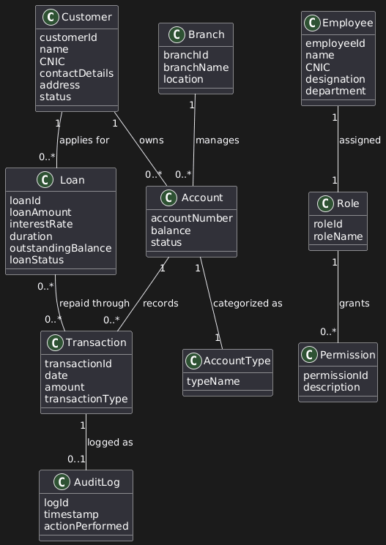

Use Case Documentation:
UC ID: BMS-UC-01
Title: Manage Customer Banking Transactions
Primary Actor: Bank Teller
Supporting Actors:Customer, System
Pre-Conditions:
- The bank employee is authenticated in the system.
- The customer is registered in the system.
- The customer has at least one active bank account.
Post-Conditions:
- The requested transaction is successfully completed and recorded.
- Account balance is updated accordingly.
- Transaction details are stored in the system and included in daily reports.

MAIN FLOW
- The bank teller initiates a banking transaction.
- The system displays options to search for a customer.
- The teller enters the customer’s Customer ID or CNIC.
3.1 Invalid Customer Details

3.1.1. The system does not find a matching customer record.
3.1.2. The system displays an error message.
3.1.3. The teller re-enters valid customer information.
- The system displays the customer profile along with associated bank accounts.
- The teller selects an active bank account.
- The system displays account details and available transaction options.
- The teller selects the transaction type (credit, debit, or fund transfer).
7.1 Fund Transfer Transaction
7.1.1. The teller selects the fund transfer option.
7.1.2. The system requests the destination account number.
7.1.3. The teller enters the destination account number.
7.1.4. The system validates the destination account.
7.1.5. The system processes the transfer and updates both accounts.
- The system prompts the teller to enter the transaction amount.
- The teller enters the transaction amount.
- The system validates the transaction details.
10.1 Account is Frozen or Closed
10.1.1. The system detects that the selected account is not active.
10.1.2. The system displays a message indicating that transactions are not allowed on this account.
10.1.3. The teller selects another active account or cancels the operation.
10.2 Insufficient Balance for Debit Transaction
10.2.1. The system checks the available balance.
10.2.2. The system displays a message indicating insufficient funds.
10.2.3. The teller enters a new amount or cancels the transaction.
- The system processes the transaction.
- The system updates the account balance.
- The system records the transaction with date, amount, and transaction type.
- The system displays a confirmation message.
- The teller confirms the transaction.
- The system generates a transaction receipt.

USE CASE DIAGRAM:
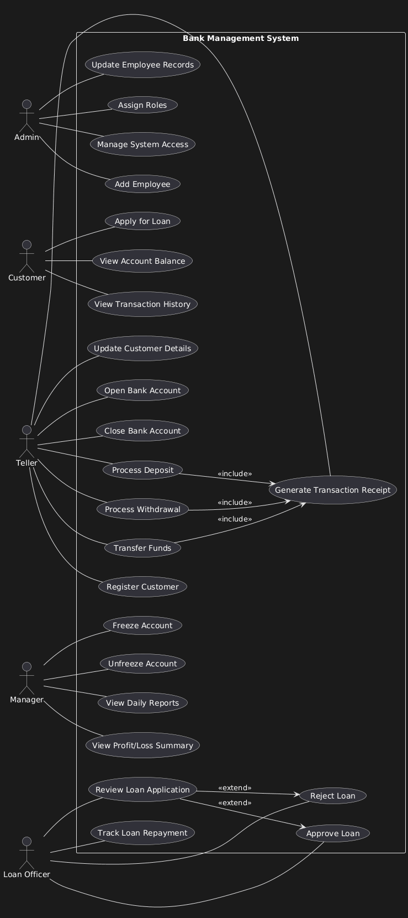

Activity Diagram — Description
The activity begins when an authorized bank employee accesses the Bank Management System. After successful authentication, the employee searches for a customer and selects one of the customer’s active bank accounts. The system validates the account status before allowing any transaction. Depending on the transaction type and account balance, the system either processes the transaction successfully or displays an appropriate error message. All successful transactions are logged, account balances are updated, and a receipt is generated at the end of the process.
